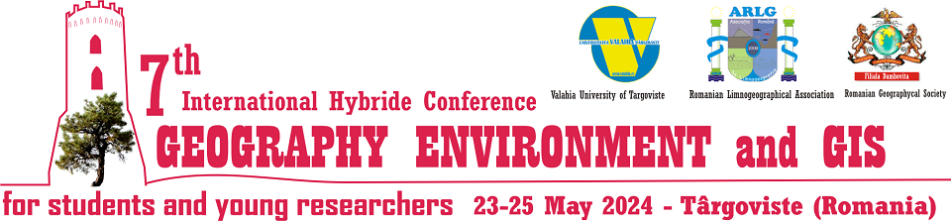

Official Conference website is:
http://www.limnology.ro/geg2024.html
Please complete this form and return by E-mail latest until April 15, 2024.
• e-mail: geg_2024@limnology.ro

Registration
Delegate | Mr. |  | Ms.
Delegate | Student | MSc | PhDs | PhD & PostDocs (<35 y)
Full Familiy name
Full First name
Company/University/Institution
Address
City
Postal Code
Country
Phone
Fax
E-mail

Type of presentation:
Oral | Poster

Themes and Topics
A. Geography
B. Environment
C. GIS

Type of participation:
In-person (face to face) | Virtual

Abstract submission (Abstract is a part of registration form)
All abstracts must be written in English with up to 800 words, including the objectives, main results, and conclusions. No graphs, tables, and references be included
TITLE
First name LAST NAME¹, First name LAST NAME² (all authors)
¹Affiliation, ²Affiliation (including email)

Abstract
Text text text text text text text text text text text text text text text text
(800 words in English, No graphs, tables, and references be included in the Abstract)

Keywords: word, word, word, word, word, word (maximum 6)

Field trip: Yes  No 

